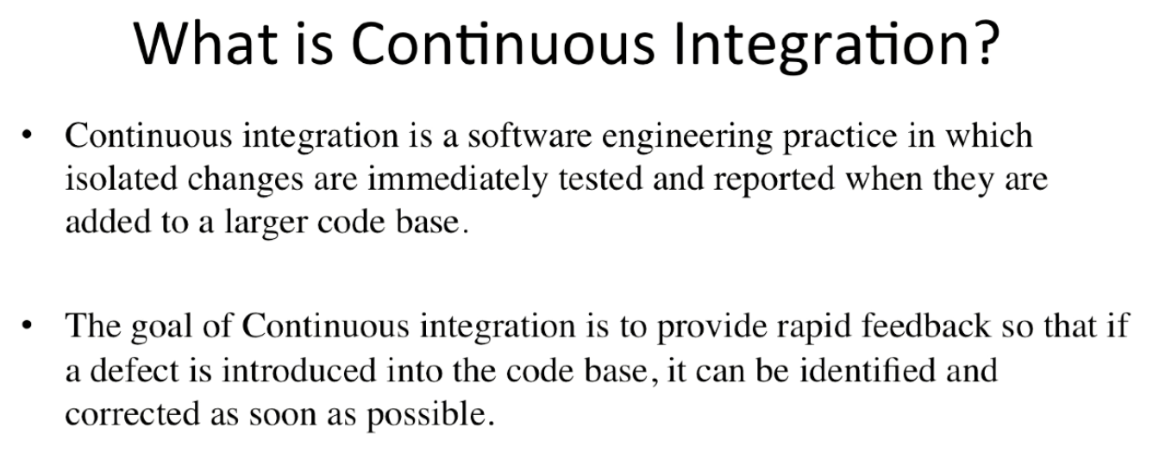

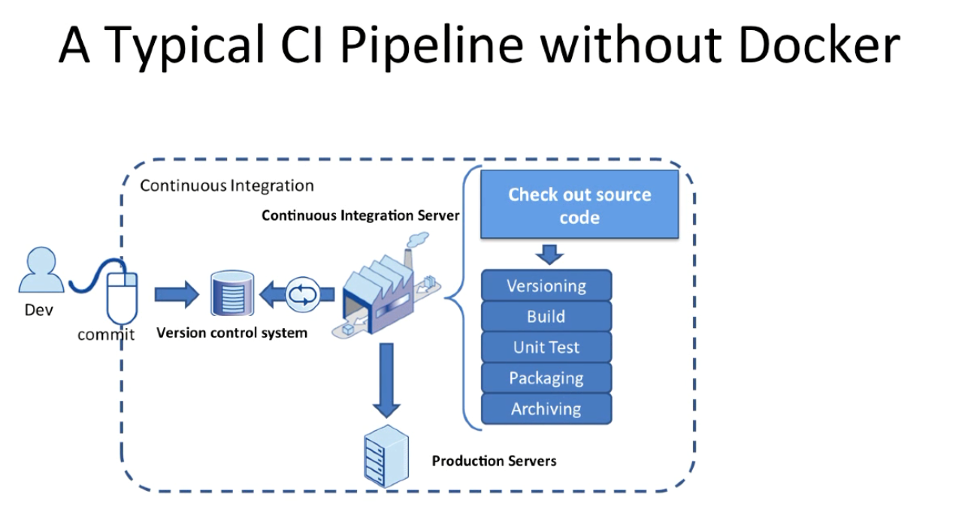

Developers checking code into local repository

Feature done -> commit changes to central repository

Continuous integration server keeps monitoring the central repository

Trigger a build on the continuos integration server

Build processes different with each application but normally it would involve checking out the latest code base, building the application and runing unit and integration tests

The continues integration server would also assign a build label to the version of the code it just build

The continuous intergration serve can also be configured to deploy the application to staging or production server after it validates the build

How docker can fit into continuous integration process

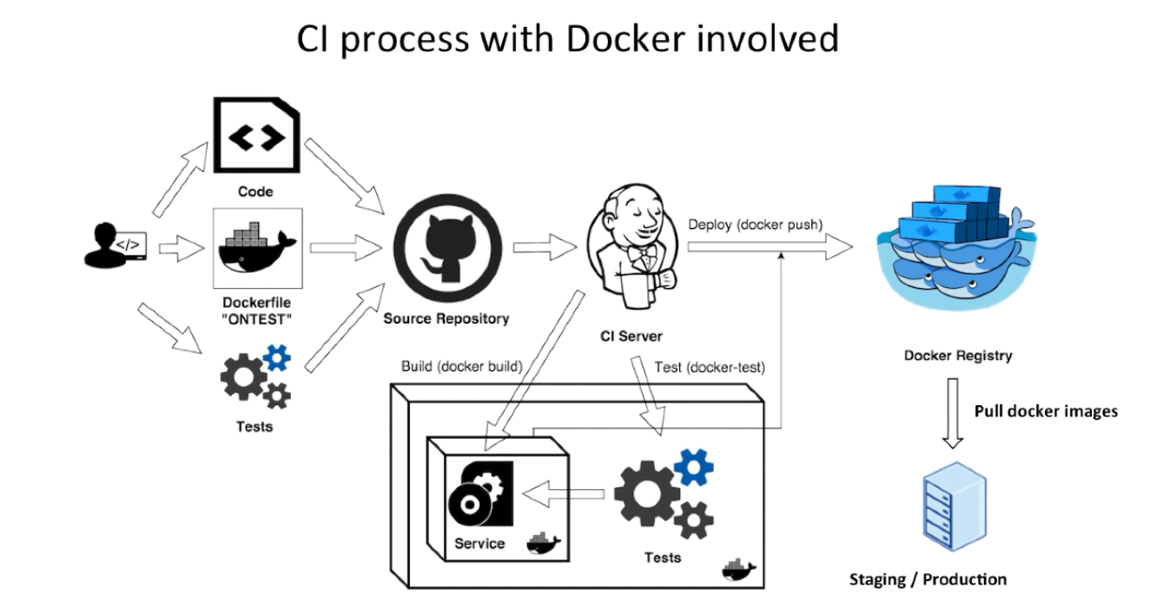

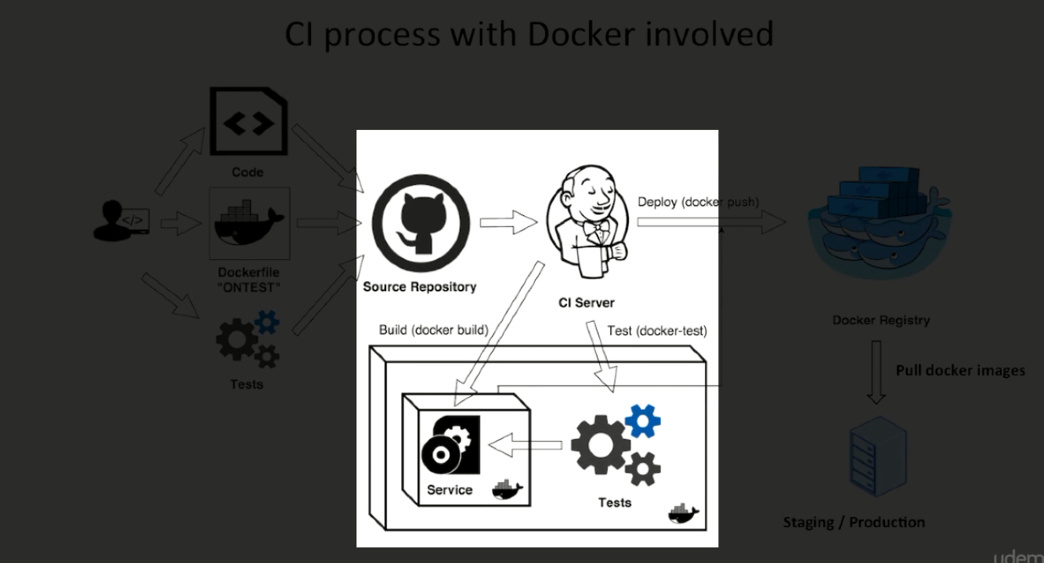

Continuous intergration serve would build docker image after it has built the application

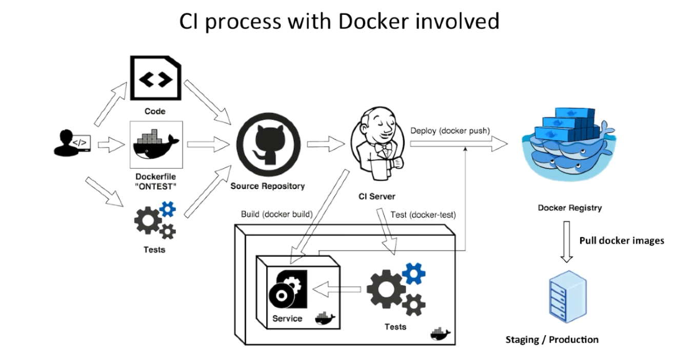

The application goes inside the image and continuous

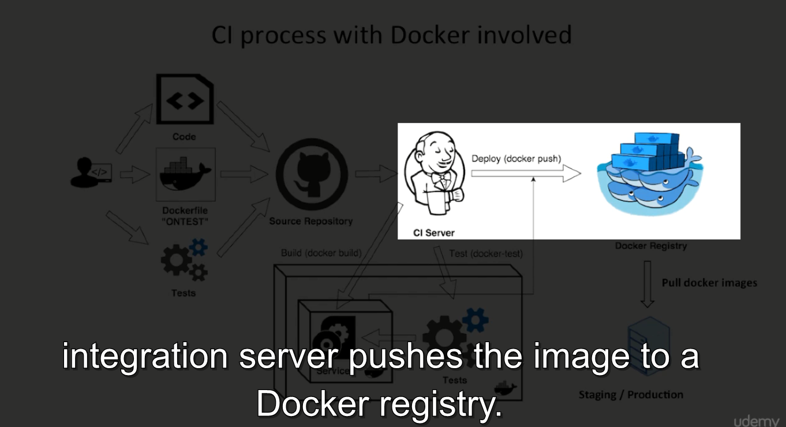

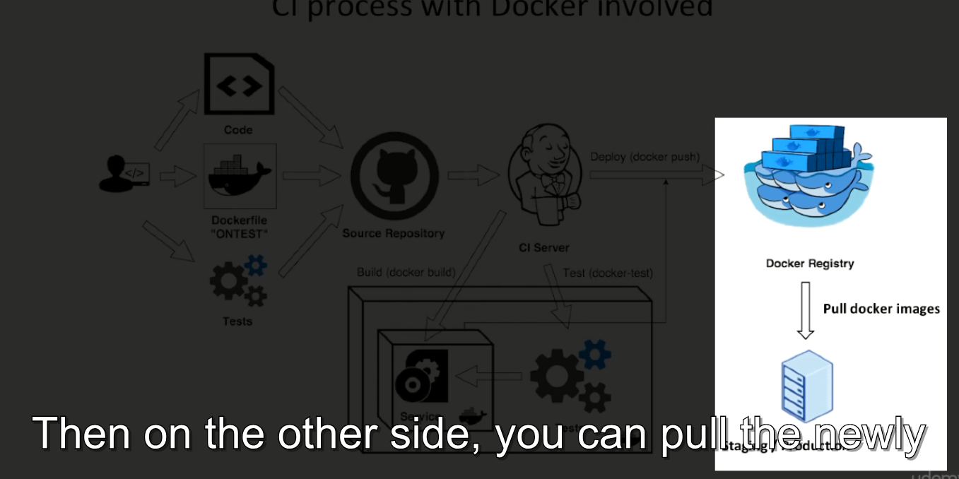 





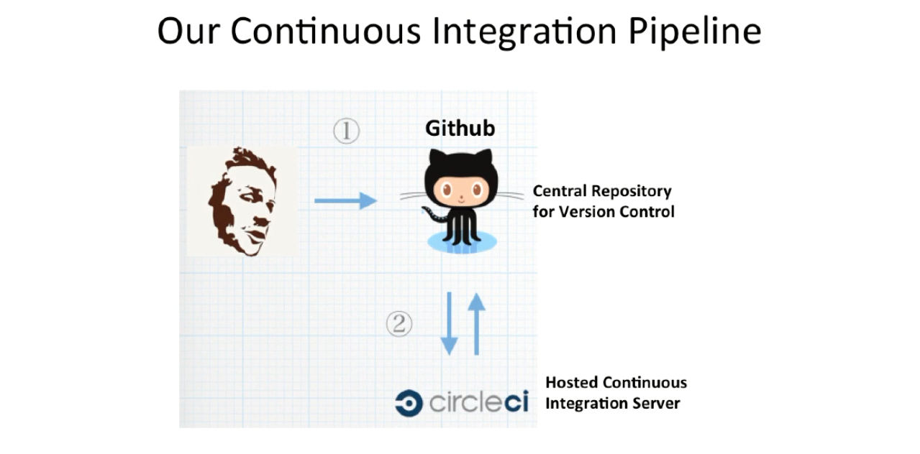



 



















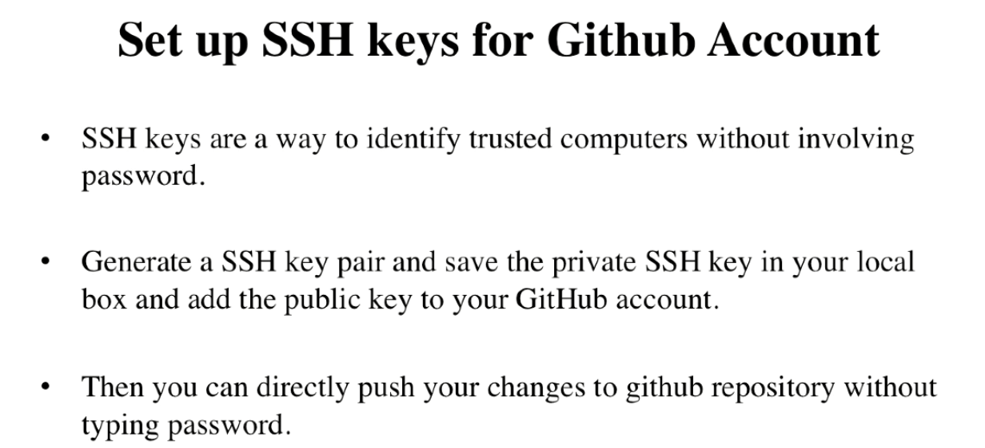





<https://help.github.com/en/github/authenticating-to-github/generating-a-new-ssh-key-and-adding-it-to-the-ssh-agent>

tạo ssh key

xem file ở lesson tiếp để tạo ssh key